

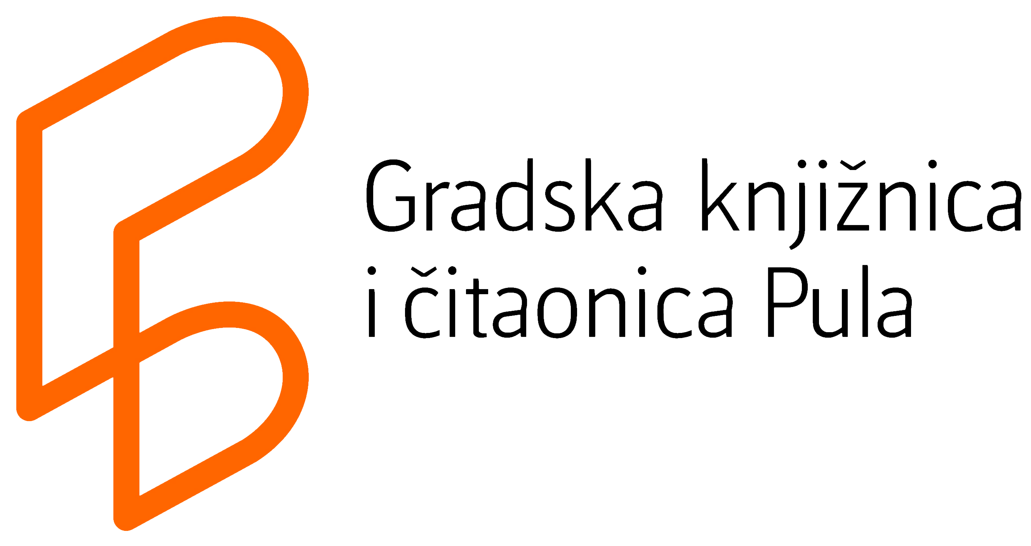

P R E L I M I N A R Y P R O G R A M M E
13th Round Table on Mobile Libraries in the Republic of Croatia and
the 7th Festival of Croatian Mobile Libraries
LET'S START A BIBLIOBUS!
How to initiate and maintain a mobile library service?
Pula, May 12th 2017
City Library and Reading Room Pula, Kandlerova street 39, Pula

  9,00h-10,00 h | Gathering and registration of participants – parking of the bibliobuses in front of the Arena
10,00h-11,30h | FESTIVAL OF MOBILE LIBRARIES – in front of the Arena
Viewing of the bibliobuses in front of the Arena
Exhibition of the posters on the Conference premises / in City Library and Reading Room Pula
Cultural and artistic programme
12,00h-15,30h | PROFESSIONAL PART OF THE CONFERENCE
12,00h-12,20h | Conference opening and introduction speeches
12,20h-12,30h | We love our bibliobus! – promotional video about Crotian mobile library services
12,30h-12,45h | Presentation of the campaign Let's start a bibliobus! by the City Library and Reading Room Pula
12,45h-13,15h | Presentation of mobile library service of Freiburg, Germany  Dr. Elisabeth Willnat, City Library Freiburg, Germany
13,15h-13,45h | INTERMISSION/ REFRESHMENTS / VIEWING OF THE POSTERS
13,45h-14,00h | Slovenian mobile libraries and new vehicles in services  Tjaša Mrgole Jukič, Public library „Ivan Potrč“ Ptuj, Republic of Slovenia  (President of the Commission for Mobile Libraries of ZBDS - Slovenian Library Association)
14,00h-14,15h | Croatian mobile library services in 2016.  Iva Pezer, City Library and Reading Room Vinkovci, Croatia  (President of the Commission for Mobile Libraries HKD – Croatian Library Association)
14,15h-14,30h | “Mobile libraries in primary schools”  Frida Bišćan, National and University Library in Zagreb
14,30h-14,45h | Presentation of a bibliobus manufacturer - Fera avto Ltd., Slovenia
14,45h-15,00h | Presentation of a bibliobus manufacturer – Multipartner Ltd., Croatia
15,00h-15,30h | Discussion and conclusions
15,30h-16,00h | Departure of the participants to the common social gathering
16,00h-18,00h | Conclusion of the Conference with the gathering of participants

POSTER PRESENTATIONS
(10,00-11,30h and during the break 13,15-13,45h)
FOREIGN MOBILE LIBRARY SERVICES
10. | Bihać, Bosnia and Herzegovina  Cantonal and University Library of the University of Bihać | Mobile library service
11. | Nyíregyháza, Hungary  „Zsigmond Móricz" County and City Library | Bibliobus
12. | Novo Mesto, Slovenia  „Miran Jarc“ Library, Novo Mesto | New bibliobus
13. | Maribor, Slovenia  Maribor Public Library | New bibliobus
14. | Kladovo, Serbia  Library – „Cultural centre“ Kladovo | Mobile libraries of Serbia  Žaklina Nikolić, Library – „Cultural centre“ Kladovo, Republic of Serbia
CROATIAN MOBILE LIBRARY SERVICES
1. | Bjelovar  Public Library "Petar Preradović"
2. | Čakovec  Public Library "Nikola Zrinski"
3. | Karlovac  City Library "Ivan Goran Kovačić"
4. | Koprivnica  Public Library and Reading Room "Fran Galović"
5. | Križevci  Public Library "Franjo Marković"
6. | Rijeka  City Library
7. | Vinkovci  City library and Reading Room
8. | Zadar  Public Library
9. | Zagreb  Zagreb City Libraries


